EMAIL / NEWSLETTER CONTENT #1

What are your Customer Interaction Management strengths and weaknesses? Take the CIM Checkup to find out.
CIMcloud is a Customer Interaction Management (CIM) software platform, providing Sage 100 users with an all-in-one solution with eCommerce capabilities for your customers and CRM functionality for your employees.
Designed specifically for product-centric B2B companies and built to integrate with Sage 100, CIMcloud will optimize the way you interact with your customers.
Ready to see how your CIM readiness stacks up against the competition? Complete the two-minute CIM Checkup today!
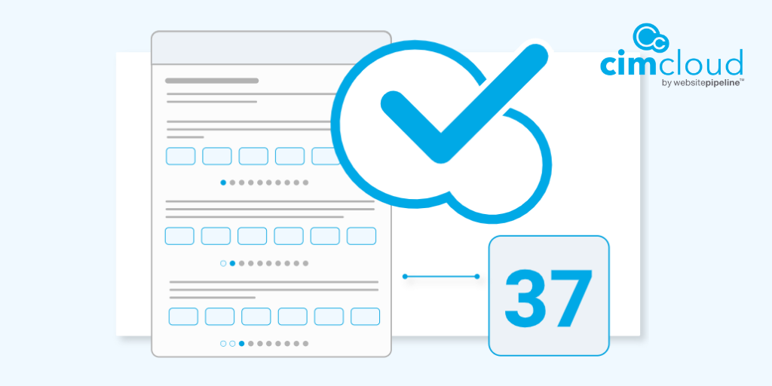

EMAIL / NEWSLETTER CONTENT #2

What is Customer Interaction Management (CIM) Software?
Solutions like CRM and E-Commerce are intended to help optimize interactions but are designed to be stand-alone products used by one specific audience (CRM by employees; E-Commerce by customers). Further, the lack of integration between these applications and ERP systems creates even more avenues for interaction data to be scattered or lost.
Customer Interaction Management (CIM) Software is a single, connected platform that captures and stores all customer interactions. It provides an all-in-one tool for customers to self-service as they choose, employees to interact more efficiently, managers to track performance, and a seamless integration between all business applications.
Watch the short video below and contact us to learn more.
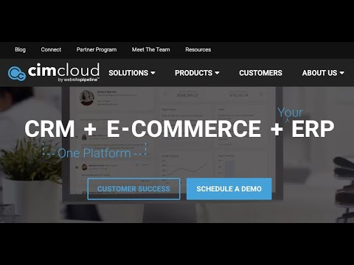

EMAIL / NEWSLETTER CONTENT #3

CIMcloud Product Overview – Grow Sales, Not Headcount
CIMcloud allows you to secure & grow your sales without growing your headcount by allowing your customers to engage in self-service and by keeping your employees informed. Learn how you can use your existing Sage 100 system and business data to keep your business moving forward.
In this recorded webinar we will cover:
- what Customer Interaction Management (CIM) includes
- what type of companies can benefit from CIM
- how CIMcloud can benefit your employees
- how CIMcloud can benefit your customers and
- how you can get started today!

Watch Now!

ADDITIONAL LOGOS / GRAPHICS
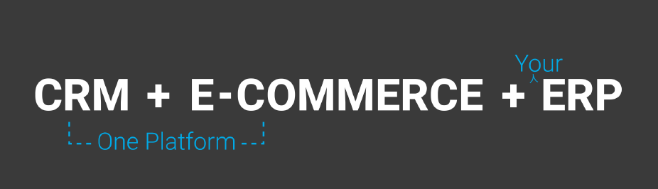

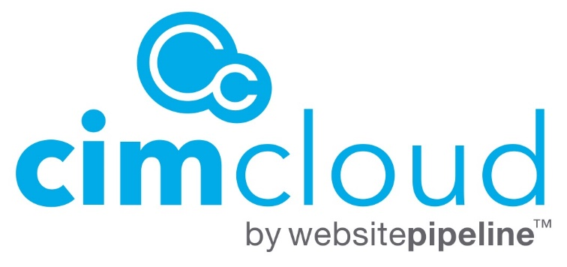
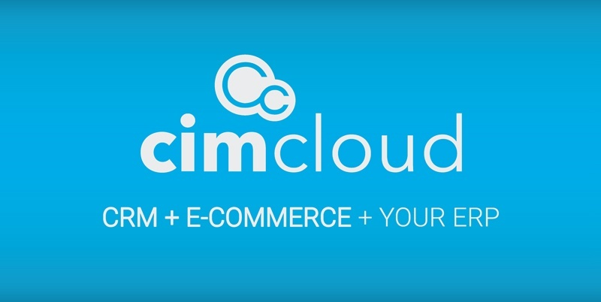
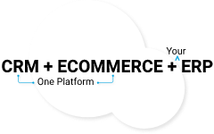

SOCIAL MEDIA POSTS
In <2 minutes, you can clearly identify your Customer Interaction Management strengths/weaknesses. Take the CIM Checkup today! https://www.cimcloud.com/resources/cim-checkup
The CIMcloud platform provides robust eCommerce capabilities for your customers and CRM functionality for your employees. Learn what’s inside: https://www.cimcloud.com/product/cimcloud-platform
